**The 15 Basic Excel Formulas Everyone Needs to Know**

Learn how to add arithmetic, string, time series, and complex formulas in Microsoft Excel.

Updated Sep 22, 2024 · 15 min read

**Contents**

* [What is an Excel Formula?](https://www.datacamp.com/tutorial/basic-excel-formulas-for-everyone#what-is-an-excel-formula?-micro)
* [Why Are Excel Formulas Important?](https://www.datacamp.com/tutorial/basic-excel-formulas-for-everyone#why-are-excel-formulas-important?-excel)
* [How to Use Excel Formulas](https://www.datacamp.com/tutorial/basic-excel-formulas-for-everyone#how-to-use-excel-formulas-addin)
* [Basic Formulas in Excel](https://www.datacamp.com/tutorial/basic-excel-formulas-for-everyone#basic-formulas-in-excel%C2%A0-nowth)
* [Upskilling Your Team in Excel](https://www.datacamp.com/tutorial/basic-excel-formulas-for-everyone#upskilling-your-team-in-excel-we've)
* [Conclusion](https://www.datacamp.com/tutorial/basic-excel-formulas-for-everyone#conclusion-micro)
* [Excel Formula FAQs](https://www.datacamp.com/tutorial/basic-excel-formulas-for-everyone#faq)

**Share**

**What is an Excel Formula?**

Microsoft Excel is a popular tool for managing data and performing data analysis. It is used for generating analytical reports, business insights, and storing operational records. To perform simple calculations or analyses on data, we need Excel formulas.

Even simple Excel formulas allow us to manipulate string, number, and date data fields. Furthermore, you can use if-else statements, find and replace, mathematics and trigonometry, finance, logical, and engineering formulas.

Unlike programming languages, you will be writing the formula name and arguments. That’s it, nothing complex. You can also use Excel-assisted user interference to add formulas.

The basic formulas in Excel are SUM(), MIN(),  MAX(), AVERAGE(), COUNT(), POWER(), CEILING(), FLOOR(), CONCAT(), TRIM(), REPLACE(), SUBSTITUTE(), LEFT(), RIGHT(), MID(), UPPER(), LOWER(), PROPER(), NOW(), TODAY(), DATEDIF(), VLOOKUP(), HLOOKUP(), and IF(). See below for guidance on each of these.

**Learn Excel Fundamentals**

**Gain skills to use Excel effectively—no experience required.**

[**Start Learning For Free**](https://www.datacamp.com/tracks/excel-fundamentals)

[***Explore essential Excel Formulas with hands-on exercises***](https://campus.datacamp.com/courses/introduction-to-excel/getting-started-with-excel?ex=1)*in our Introduction to Excel course.*

*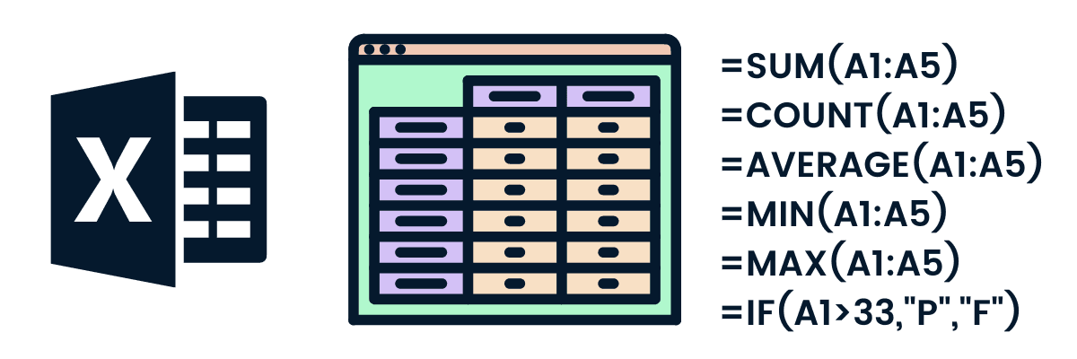*

**Why Are Excel Formulas Important?**

Excel formulas are essential for several reasons:

1. **Efficiency**: They automate repetitive tasks, saving time and reducing manual errors.
2. **Data analysis**: Excel's range of formulas enables sophisticated data analysis, crucial for informed decision-making.
3. **Accuracy**: Formulas ensure consistent and accurate results, essential in fields like finance and accounting.
4. **Data manipulation**: They allow for efficient sorting, filtering, and manipulation of large datasets.
5. **Accessibility**: Excel provides a user-friendly platform, making complex data analysis accessible to non-technical users.
6. **Versatility**: Widely used across various industries, proficiency in Excel formulas enhances employability and career advancement.
7. **Customization**: Excel offers customizable formula options to meet specific data handling needs.

In essence, Excel formulas are a foundational tool for effective data management, analysis, and decision-making.

**Advance Your Career with Excel**

Gain the skills to maximize Excel—no experience required.

[**Start Today for Free**](https://www.datacamp.com/tracks/excel-fundamentals)

**How to Use Excel Formulas**

Adding the Excel formula is relatively easy. It will come to you naturally if you are familiar with any business intelligence software.

The most effective and fast way to use formulas is by adding them manually. In the example below, we are calculating the BMI (Body Mass Index) of the athletes shown in the table.

**BMI = weight (KG)/ (Height (m))2**

1. Choose the cell for the resulting output. You can use the mouse to select the cell or use the arrow key to navigate.
2. Type “**=**” in the cell. The equal sign will appear in the cell and formula bar.
3. Type the address of the cell that we want to use for our calculation. In our case, it is **E2** (weight/KG).
4. Add divide sign “**/**”
5. To convert height from centimeters to a meter, we will divide the **D2** by 100.
6. Take the squared “**^2**” of the height and press **Enter.**

**Note**: To get the address of any cell, you need to look at the column name (A, B, C, … ) and combine it with a row number (1, 2, 3, …). For example, A2, B5, and C12

That’s it; we have successfully calculated the BMI of A Dijiang.



Adding Excel formula | Author

We can also add the Excel formula by using assisted GUI. It is simple.

In the example below, we will be using GUI to add an **IF** formula to convert ‘M’ to ‘Male’ and ‘F’ to Female.

1. Click on the **fx** button next to the formula bar.
2. It will pop up in the window with the most used function.
3. You can either search for the specific formula or select the formula by scrolling. In our case, we will be specifying the IF formula.
4. Add the logic B2=’M” into the **logical\_test** argument.
5. Add “Male” in value\_if\_true argument and “Female” in value\_if\_false argument.

The formula works similarly to the if else statement. If the logical\_test statement is TRUE, the formula will return “Male” otherwise “Female.”



Excel formula using UI | Author

**How to insert formulas in excel for an entire column**

We have learned to add the formula to a single row. Now, we will learn to apply the same formula to the entire column.

There are multiple ways to add formulas:

* **Dragging down the fill handle**: when you select the cell, you will see the small green box at the bottom right. It is called a fill handle. Click and hold the fill handle and drag it down to the last row. It is commonly used to apply formulas to selected rows.
* **Double click the fill handle**: select the cell with the formula and double click the fill handle. Within seconds it will apply the formula to the entire column.
* **Shortcut**: select the cell with the formula and the empty cells below it. Press CTRL + D to apply the formula. Make sure you are not selecting anything above the formula cell.
* **Copy-pasting**: copy the cell with the formula (CTRL + C), select the empty rows in a column, and paste it (CTRL + V). Make sure you are not using a fill handle to select the rows.

The visual representation below shows all the ways we can apply the formula to multiple cells.



Formula for an entire column | Author

**Basic Formulas in Excel**

Now that we know how to use Excel formulas, it’s time to learn about 15 basic Excel formulas on a small subset of the [**Olympics**](https://www.datacamp.com/workspace/datasets/python-olympics) dataset from DataCamp. To keep things simple, we will mainly use the name, sex, age, height, and weight columns of four athletes' records.

**1. SUM**

The SUM() formula performs addition on selected cells. It works on cells containing numerical values and requires two or more cells.

In our case, we will be applying the SUM formula to a range of cells from C2 to C5 and storing the result on C6. It will add 24, 23, 21, and 31. You can also apply this formula to multiple columns.

=SUM(C2:C5)

[**Powered By**](https://www.datacamp.com/datalab)

**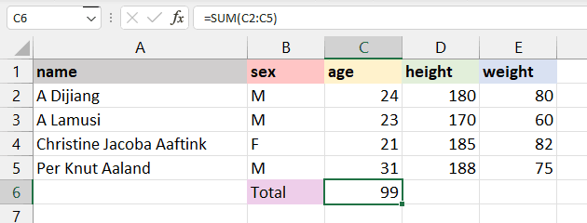**

**2. MIN and MAX**

The MIN() formula requires a range of cells, and it returns the minimum value. For example, we want to display the minimum weight among all athletes on the E6 cell. The MIN formula will search for the minimum value and show 60.

=MIN(E2:E5)

[**Powered By**](https://www.datacamp.com/datalab)

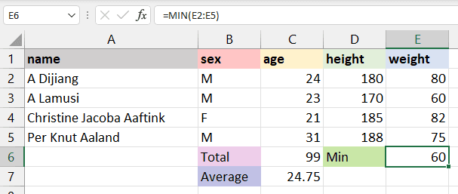

The MAX() formula is the opposite of MIN(). It will return the maximum value from the selected range of cells. The formula will look for the maximum value and return 82.

=MAX(E2:E5)

[**Powered By**](https://www.datacamp.com/datalab)

**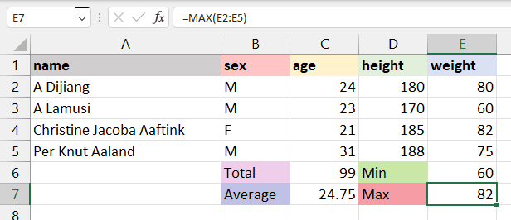**

**3. AVERAGE**

The AVERAGE() formula calculates the average of selected cells. You can provide a range of cells (C2:C5) or select individual cells (C2, C3, C5).

To calculate the average of athletes, we will select the **age** column, apply the average formula, and return the result to the C7 cell. It will sum up the total values in the selected cells and divide them by 4.

=AVERAGE(C2:C5)

[**Powered By**](https://www.datacamp.com/datalab)

**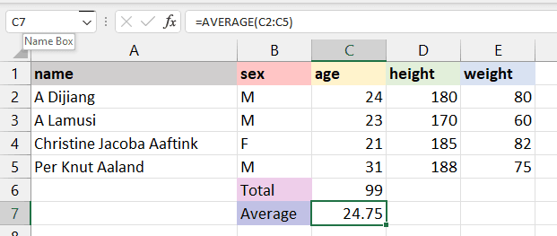**

**4. COUNT**

The COUNT() formula counts the total number of selected cells. It will not count the blank cells and different data formats other than numeric.

We will count the total number of athlete weights, and it will return 4, as we don’t have missing values or strings.

=COUNT(E2:E5)

[**Powered By**](https://www.datacamp.com/datalab)

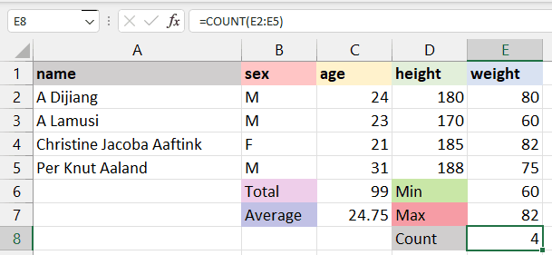

To count all types of cells (date-time, string, numerical), you need to use the COUNTA() formula.

The COUNTA() formula does not count missing values. For blank cells, use COUNTBLANK().

**5. POWER**

In the beginning, we learned to add power using “^”, which is not an efficient way of applying power to a cell. Instead, we recommended using the POWER() formula to square, cube, or apply any raise to power to your cell.

In our case, we have divided D2 by 100 to get height in meters and squared it by using the POWER formula with the second argument as 2.

=POWER(D2/100,2)

[**Powered By**](https://www.datacamp.com/datalab)

**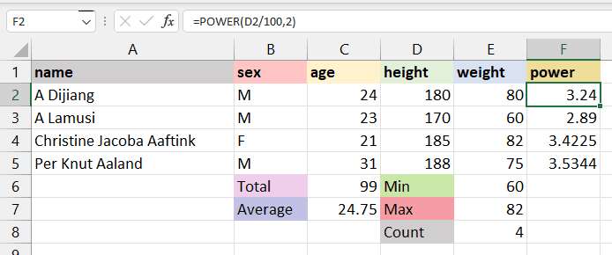**

**6. CEILING and FLOOR**

The CEILING() formula rounds a number **up** to the nearest given multiple. In our case, we will round 3.24 up to a multiple of 1 and get 4. If the multiple is 5, it will round up the number 3.24 to 5.

=CEILING(F2,1)

[**Powered By**](https://www.datacamp.com/datalab)

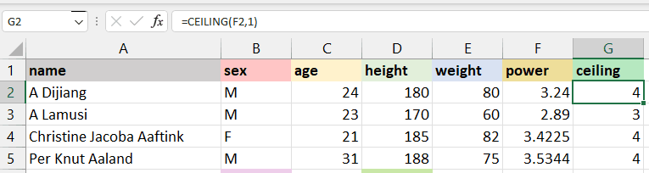

The FLOOR() rounds a number **down** to the nearest given multiple. As we can see in the image below, instead of converting 3.24 to 4, it has rounded the number to 3.

=FLOOR(F2,1)

[**Powered By**](https://www.datacamp.com/datalab)

**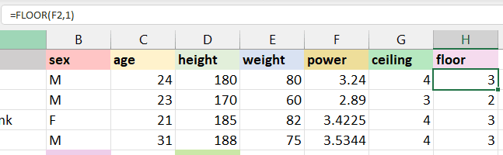**

**7. CONCAT**

The CONCAT() Excel formula joins or merges multiple strings or cells with strings into one. For example, if we want to join the **age** and **sex** of the athletes, we will use CONCAT. The formula will automatically convert a numeric value from **age** to string and combine it.

**“24”+“M” = “24M”**

=CONCAT(C2,B2)

[**Powered By**](https://www.datacamp.com/datalab)

**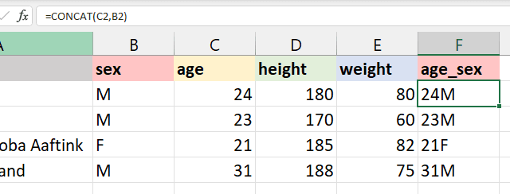**

**8. TRIM**

TRIM() is used to remove extra spaces from the start, middle, and end. It is commonly used to identify duplicate values in cells, and for some reason, extra space makes it unique.

**For example**:

1. There are extra two spaces at A3 “A   Lamusi”, and it has been successfully removed by TRIM.
2. At A4 “ Christie Jacoba Aaftink”, there is extra space at the start, and without writing any complex formula, the TRIM has removed it.

=TRIM(A4)

[**Powered By**](https://www.datacamp.com/datalab)

**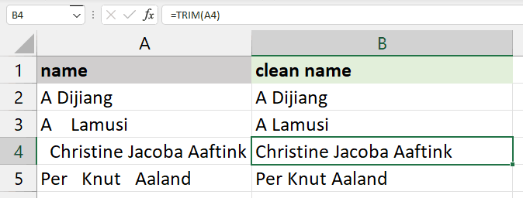**

**9. REPLACE and SUBSTITUTE**

REPLACE() is used for replacing part of the string with a new string.

**REPLACE(old\_text, start\_num, num\_chars, new\_text)**

* old\_text is the original text or cell containing the text.
* start\_num is the index position that you want to start replacing the character.
* num\_chars refers to the number of characters you want to replace.
* new\_text indicates the new text that you want to replace with old text.

For example, we will change A Dijiang with B Dijiang by providing the positing of character, which is 1, the number of characters that we want to replace, which is also 1, and the new character “B”.

=REPLACE(A2,1,1,"B")

[**Powered By**](https://www.datacamp.com/datalab)

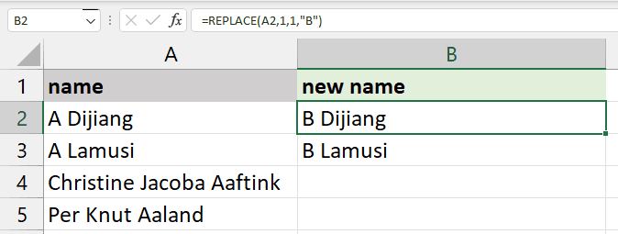

The SUBSTITUTE() formula is similar to REPLACE(). Instead of providing the location of a character or the number of characters, we will only provide old text and new text.

**SUBSTITUTE(text, old\_text, new\_text, [instance\_num])**

In our case, we are replacing "Jacoba" with "Rahim" to display the result on A4 cell “Christine Rahim Aaftink.”

This formula is quite useful as it does not change the text without “Jacoba” as shown below in cell A5, “Per Knut Aaland.” Whereas, REPLACE will replace the text every time.

=SUBSTITUTE(A4,"Jacoba","Rahim")

[**Powered By**](https://www.datacamp.com/datalab)

**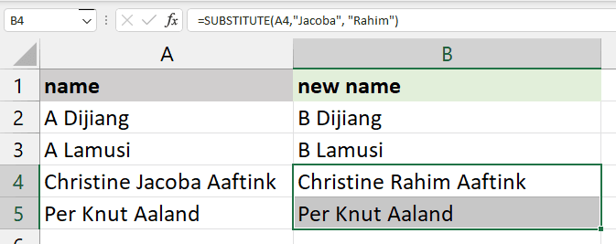**

**10. LEFT, RIGHT, and MID**

The LEFT() formula returns the number of characters from the start of the string or text.

For example, to display the first name from the text “Christine Jacoba Aaftink”, you will use LEFT with 9  numbers of characters. As a result, it will show the first nine characters; “Christine.”

=LEFT(A2,9)

[**Powered By**](https://www.datacamp.com/datalab)

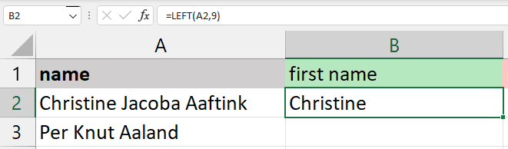

The MID() formula requires starting position and length to extract the characters from the middle.

For example, if you want to display a middle name, you will start with “J” which is at the 11th position, and 6 for the length of the middle name “Jacoba”.

=MID(A2,11,6)

[**Powered By**](https://www.datacamp.com/datalab)

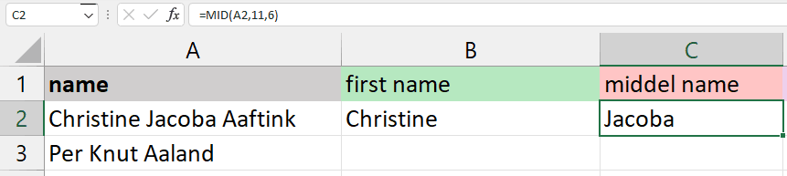

The RIGHT() formula will return the number of characters from the end. You just need to provide a number of characters.

For example, to display the last name “Aaftink,” we will use RIGHT with seven characters.

=RIGHT(A2,7)

[**Powered By**](https://www.datacamp.com/datalab)

**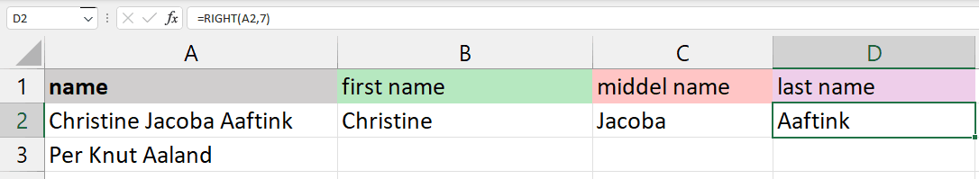**

**11. UPPER, LOWER, and PROPER**

The UPPER(), LOWER(), and PROPER() formulas are basic string operations. You can find similar in Tableau or in Python. These formulas only require a text, the location of the cell containing string, or the range of cells with string.

UPPER() will convert all the letters in the text to uppercase.

=UPPER(A1:F1)

[**Powered By**](https://www.datacamp.com/datalab)

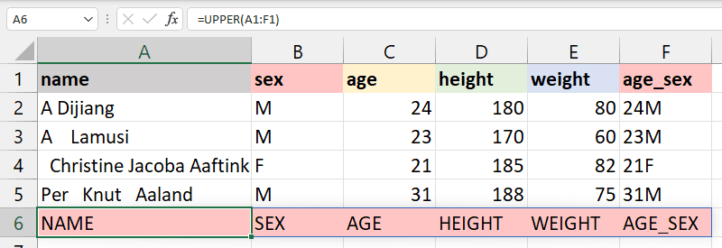

LOWER() will convert the selected text lower case.

=LOWER(A1:F1)

[**Powered By**](https://www.datacamp.com/datalab)

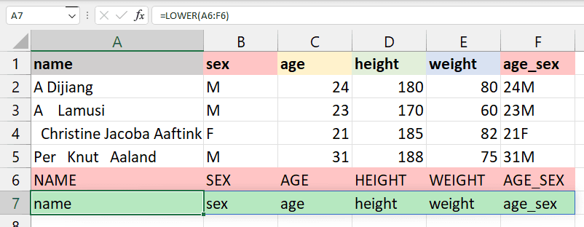

PROPER() will convert the string to the proper case. For example, the first letter in each word will be capitalized, and the rest of them will be lowercase.

=PROPER(A1:F1)

[**Powered By**](https://www.datacamp.com/datalab)

**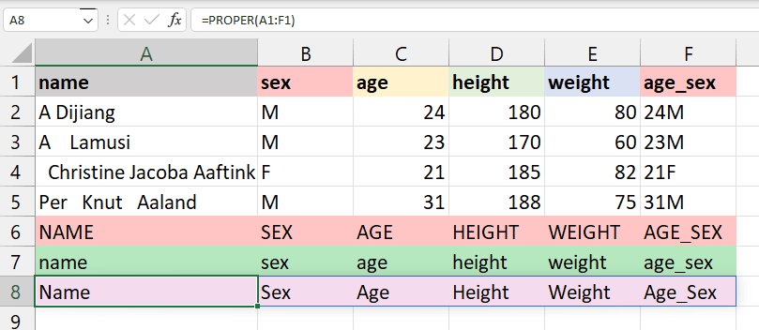**

**12. NOW and TODAY**

NOW() returns the current time and date, and TODAY() returns only the current date. These are quite simple, and we will use them to extract a day, month, year, hours, and minutes from any date time data cell.

The example below returns the current date and time.

=NOW()

[**Powered By**](https://www.datacamp.com/datalab)

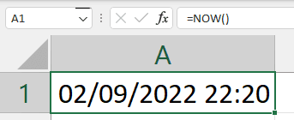

To extract the seconds from the time, you will use the SECOND() formula.

=SECOND(NOW())

[**Powered By**](https://www.datacamp.com/datalab)

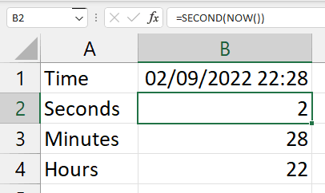

Similarly, TODAY() will return only the current date.

=TODAY()

[**Powered By**](https://www.datacamp.com/datalab)

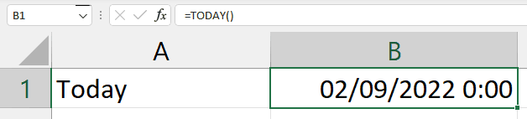

To extract the day, you will use the DAY() formula.

Furthermore, you can extract month, year, weekday, day names, hours, and minutes from the date time data field.

=DAY(TODAY())

[**Powered By**](https://www.datacamp.com/datalab)

**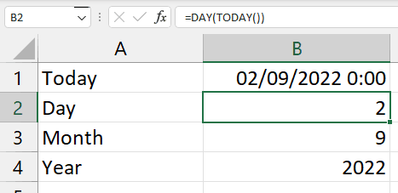**

**13. DATEDIF**

It is the most used formula for time series data sets. The DATEDIF() calculates the difference between two dates and returns the number of days, months, weeks, or years based on your preference.

In the example below, we want to return the date difference in days by providing “d” for unit arguments. Make sure that the first argument is the start date and the second argument in the formula is the end date.

**start\_date < end\_date**

=DATEDIF(A2,B2,"d")

[**Powered By**](https://www.datacamp.com/datalab)

**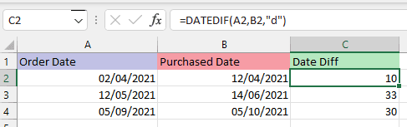**

**14. VLOOKUP and HLOOKUP**

The **worksheet1** that we will use in this section contains all the data from the [**Olympics**](https://www.datacamp.com/workspace/datasets/python-olympics) dataset.

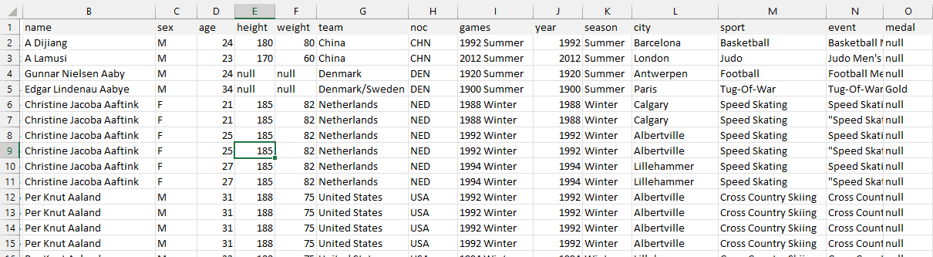

worksheet1

The VLOOKUP() formula searches for the value in the leftmost column of the table array and returns the value from the same row from the specified columns.

**VLOOKUP(lookup\_value, table\_array, col\_index, range\_lookup)**

* **lookup\_value**: the value you are looking for that is present in the first column.
* **table\_array**: the range of the table, worksheet, or selected cell with multiple columns.
* **col\_index:** the position of the column to extract the value.
* **range\_lookup**: “True” is used for the approximate match (default), and “FALSE” is used for the exact match.

In our case, we are looking for A Dijiang (A2) from selected columns and rows of worksheet1 (B2:H20). The VLOOKUP formula will check the name column in worksheet one and return the 6th column value that is team “China”.

=VLOOKUP(A2,worksheet1!B2:H20,6,FALSE)

[**Powered By**](https://www.datacamp.com/datalab)

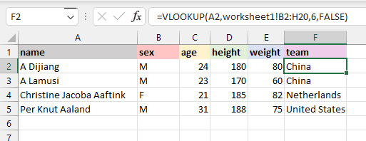

The HLOOKUP() searches for the value in the first row instead of the first column. It returns the value from the same column and the row you specified.

**HLOOKUP(lookup\_value, table\_array, row\_index, range\_lookup)**

In our case, we will display A Dijaing’s **sex** on the D8 cell. The HLOOKUP formula will look for the name in the first row and return the value “M'' from the 2nd row of the same column. The range\_lookup is kept FALSE in both cases for the exact match.

=HLOOKUP(B1,B1;E5,2,FALSE)

[**Powered By**](https://www.datacamp.com/datalab)

**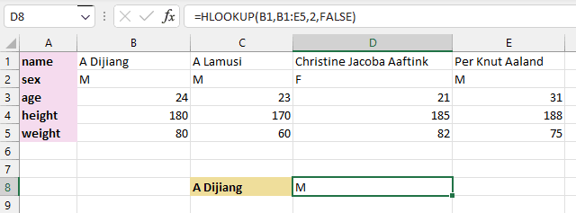**

**15. IF**

The IF() Excel formula is straightforward. It is similar to an if-else statement in a programming language. We will provide the logic of the formula. If the logic is correct, it will return a certain value; if the logic is False, it will return a different value.

For example, if the BMI of athletics is less than 23.9, the formula will return the string “Fit”, else “Unfit”. It is quite useful to convert numerical values into categories.

=IF(G2<24.9,"Fit,"Unfit")

[**Powered By**](https://www.datacamp.com/datalab)

**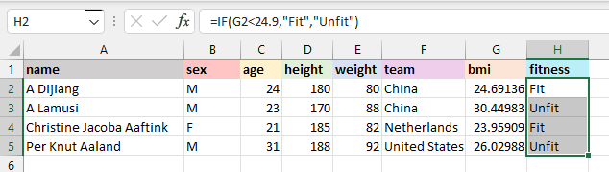**

**Upskilling Your Team in Excel**

We've covered the Excel formulas that everyone needs to know, but upskilling multiple people in this area isn't always straightforward. We have a separate guide that covers [**corporate Excel training**](https://www.datacamp.com/blog/corporate-excel-training) in depth, but it's worth mentioning here.

We've established that Excel is more than just a spreadsheet tool—it's often essential for effective data management, financial analysis, and decision-making. As such, investing in Excel training can boost your team's productivity, accuracy, and overall efficiency. Key benefits include:

* **Data analysis**: Advanced Excel skills enable more insightful data interpretation, aiding better decision-making.
* **Efficiency**: Automation through spreadsheets can reduce manual work and errors.
* **Financial precision**: Mastery of functions like VLOOKUP and pivot tables enhances financial management.
* **Operational streamlining**: Excel's data manipulation tools can improve the handling of large datasets, optimizing operations.
* **Competitive edge**: Proficiency in Excel provides a significant advantage in refining processes and gaining insights.

If you're looking to train your team in Excel skills, from the basics to more advanced formulas, **[DataCamp For Business](https://www.datacamp.com/business" \t "_blank)** is the ideal tool. Whether your team is 2 people or 10,000 people, DataCamp For Business offers a host of dedicated Excel and spreadsheet learning materials, the ability to create custom tracks to scale and tailor your learning experience, and detailed reporting and insights to measure the impact of your training. [**Request a demo today**](https://www.datacamp.com/business/demo) to get started.

**Conclusion**

Microsoft Excel is a powerful and easy-to-use application for data analysis and reporting. In this post, we have learned the importance of basic Excel formulas and how they provide us extra ability to perform complex calculations. Furthermore, we have learned about various ways of adding formulas to worksheets and looked in detail at the essential basic Excel formulas.

To learn more about Excel and how to use these formulas for data analysis, take our [**Data Analysis in Excel**](https://www.datacamp.com/courses/data-analysis-in-excel) course. It will teach you the basics of data exploration, processing, and analysis. If you are fond of the Google stack and use Google Sheets, try [**Data Analysis in Spreadsheet**](https://www.datacamp.com/courses/data-analysis-in-spreadsheets).

You can also take another step forward by learning the[**fundamentals of a spreadsheet**](https://www.datacamp.com/tracks/spreadsheet-fundamentals). You will learn about data analysis, advanced data manipulation techniques, pivot tables, and data visualization. Finally, you can check out our Excel Formulas [**cheat sheet**](https://www.datacamp.com/cheat-sheet/getting-started-with-excel-cheat-sheet) for a quick reference guide and learn more about [**data types in Excel**](https://www.datacamp.com/tutorial/data-types-in-excel).